|  |  |
| --- | --- |
| **1. Introduction System Design**  **2. Components**  **3. Client Server Architecture**  **4. Proxies**  **5. Data & Data Flow**  **6. Databases types: SQL, NoSQL, Column, Search, Key Value**  **7. Application & Services**  **8. API**  **9. Caching**  **10. REST API**  **11. Message Queues**  **12. Pub Sub Messaging**  **13 Performance Metrics**  **14 Performance Metrics of components in a software**  **15 Fault & Failure in distributed systems**  **16 Horizontal vs vertical scaling**  **17 Database Replication**  **18 CAP Theorem**  **19 What is Database Sharding, Logical and Physical Shards, Dynamic vs Algorithmic Sharding**  **20 Hashing, Consistent Hashing** | **https://www.youtube.com/channel/UCTCfIFumvw06VZmMSce_pSw/videos**  [**https://softwarearchitect.ca/**](https://softwarearchitect.ca/)  [**https://www.fullstack.cafe/interview-questions/api-design**](https://www.fullstack.cafe/interview-questions/api-design)  [**https://github.com/growthbook/growthbook**](https://github.com/growthbook/growthbook)  [**https://www.youtube.com/c/sudoCODE/videos**](https://www.youtube.com/c/sudoCODE/videos)  [**https://www.youtube.com/watch?v=07BVxmVFDGY**](https://www.youtube.com/watch?v=07BVxmVFDGY)  **API Headers**  **5 mistakes I made in System Design Interviews that you should avoid**  **Foundation of System Design Interview starting with Functional vs Non Functional Requirements**  **How to solve capacity estimation problems faster? | Thumb rules and quick tips**  **System Design Books**  **High Level (HLD) Vs Low Level(LL) Design**  **CDN** |

**1.** **Introduction System Design**

**what is the system?**

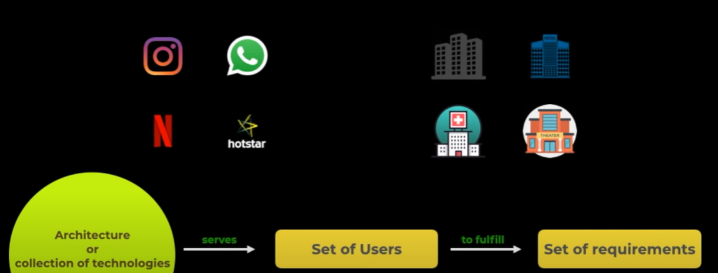

a system is a loosely used term for an architecture or collection of software or technology that communicate with each other interact with each other in order to serve a certain set of users with a certain set of requirements

For example

* image sharing system (Instagram), texting (whatsapp), streaming systems (Netflix, hotstar)
* in real life also there are systems like buildings, hotels, hospitals, theaters.

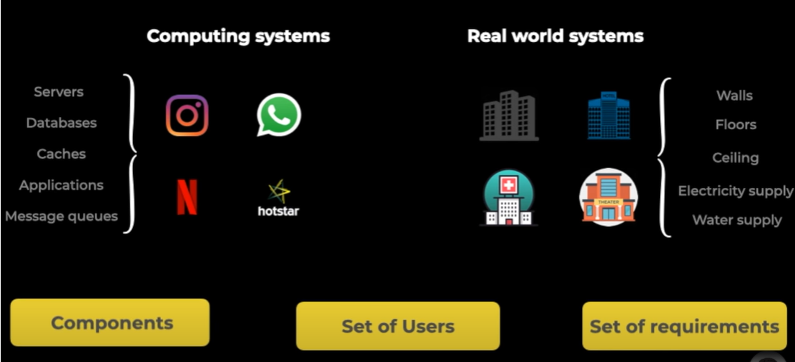

* for example in buildings all the buildings have walls, floors, ceilings, electrical supply, water supply etc but different buildings serve different users with different set of requirements
* similarly in software systems even though basic building components are same but they serve different kind of users with different set of requirements.

**what is design**

Design is a process of understanding the user requirements and selecting the components modules and software technologies, how they are going to be communicating with each other to actually serve the need of the system.

Whole process of selecting those components, understanding the needs of the user and the requirements and also factoring in different constraints and concerns.

Even though the components of systems can be same the design for two different systems looks very different

let's say design of a duplex is going to look very different from design of a skyscraper

similarly design of a website that serves a static content or just like one or two videos is going to be very different from a streaming platform like netflix

**why system design**

In order to understand and develop this skill of designing, certain kind of systems which serve to larger scale and larger users the process of system design comes into the picture

why system design is needed as a skill or why system design is such a popular topic

The whole process is actually very complicated it needs a lot of experience expertise and knowledge about software technologies etc in order to build successful large scale systems in real world actually this is not done by one person but as an engineer one should know about the components, the trade-offs, the problems that have to be solved, the concerns of where systems can fail, how to handle those failures, what are the concerns and the constraints that have to be addressed and taken care

**2.** **Components**

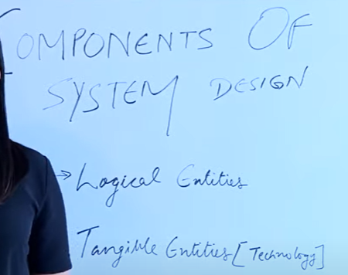

Components which are the basic building blocks of system

Components could be divided into two parts 1) logical entities and 2) tangible entities

|  |  |  |  |
| --- | --- | --- | --- |
|  | **Logical entities** are responsible for making up for the access system. All the systems are built up of data. Dbs are the core of any system, which allows you to store the data. so that it can be available to the users in a later run.  How do users interact( read, write) with databases? Communication through Application or Services (which is mobile, desktop or website) Layer. |  | Applications is running on a machine and dbs is running on another machine. Now these two machines have to interact with each other and that happens through communication protocols  **Communication protocols** is another logical entity which makes the communication between different machines, so that the components of the system can interact with each other  The way applications communicate over network via communication protocols like http, tcp etc  Similarly application or services communicate on a software level with each other through components like request in the form of apis, rpcs. |

all the systems may or may not have a **presentation layer**.

Systems do have a presentation layer - the mobile, the desktop, the web apps

Systems do not have a presentation layer - if you are making a logger or a logging system which just collects the logs of your application (it may or may not need a presentation layer)

The way system is presented to the user so that the users can interact with it comes under one more logical entity of a system

All these components run on some computers or instances which are available by some cloud providers like azure, aws, google.

|  |  |
| --- | --- |
| **Tangible entities** or technologies that make up for these components  **F**or databases like mongodb, mysql, Cassandra, redis etc.  **F**or application and services or the code and their communication like apis, rpcs, etc  For presentation layer (front-end app), which are built using frameworks like amber, react, etc  For android /ios apps have their own native code bases in order to develop those applications  For the security of the systems, have certain security mechanisms and protocols to secure the data and avoid the attacks.  All these technologies are actually deployed or put on real hardware instances or computers which are provided by the cloud providers |  |

Now let's merge all , see a very superficial view of what our system looks like

There is a **presentation layer** where the system could be presented, where the user can interact with the system through a desktop, website or a mobile app which interacts in the backend with our system with the applications.

**Applications** interact with the databases for the exchange of data

All the machines (applications and databases) are actually deployed on instances physical **computers** which interact with each other over these blue lines which is **network**

these application code interact with each other through **apis**, messages

All these are housed inside a cloud provider like aws or gcp etc which is called **infrastructure**

Let's go back to our example of building, has walls floors, terraces, fire exit, electrical supply etc

similarly a system is composed of applications, databases, caches, load balancers, client interfaces, network request, security layer and infrastructure

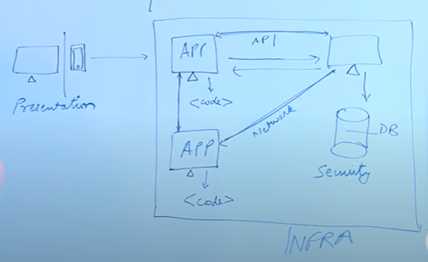

**3.** **Client Server Architecture**

|  |  |  |  |
| --- | --- | --- | --- |
| **1st component** of system design, which is CSA. |  | **What is CSA?**  Basic 2 tier CSA - Client request for some particular data(image,text) from server. Server responds with the data.  Some logical manipulation (example, filtered house list) has to be done over the data. |  |

**Understanding Thick & Thin Client**

**Thick Client** - It’s not necessary logic sits in server. Logical manipulation or processing sits in client side. For example MS Outlook, video editing sw.

**Thin Client** – Logic or processing sits in server side, means client doesn’t have many responsibilities. Example streaming platform Netfilx, hotstar. Even though presentation layer, but majority processing happens in server/backend side.

**2 Tier, 3 Tier and N Tier Architecture**

**3 Tier** - Processing is huge, it has be done on server side Or Data is heavy , lot of amounts of data that has been to stored in process . Logic and Data layer broken (2 tier). Logic which is application and Data which is database.

**N Tier** – In some cases 3-tier is enough, system design is large or complex applications, where even processing or requirements can’t be full fill in efficient manner using 3 tier layer. Then they are multiple layer in between, for example **caching layer** between logic and data OR **Load balancer or proxy** in between client and logic

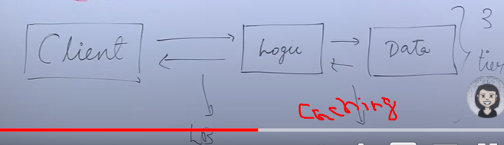

How do you decide if you have to select thin, thick, 2tier or 3 tier

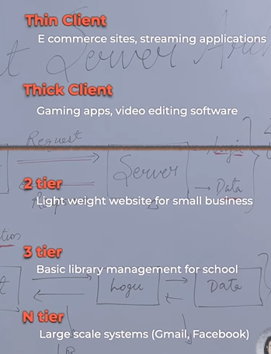

**4.** **Proxies**

|  |  |
| --- | --- |
|  | **What is Proxy?** On behalf, for example when you can’t attend the class , you ask your friend attend the class behalf of you. Here friend is proxy.  **2 Types of** Proxy – Forward and Reverse |



**Forward Proxy** – A Machine sits between client and server towards the client side, which talks to the server on behalf the client. Client sends request to the proxy, proxy sends to the server, server response back to cleint. Here client never talks to the server, the proxy behalf of the client talks to the server.

**Why It’s useful?** 1. For anonymity , where server doesn’t know IP of the client, server only knows IP of proxy.

2. In institution, where there can be multiple clients, all traffic is controls or monitored through forward proxy

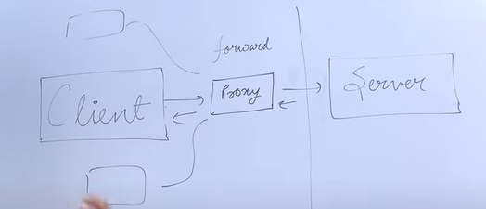

3. Block access to certain sites (malicious)

4.Caching response at forward proxy site.

**Pros/Cons -** if country, organization, work place block access to some sites, in this case proxy can be used to by pass the rules & haves access to sites (useful or not useful)

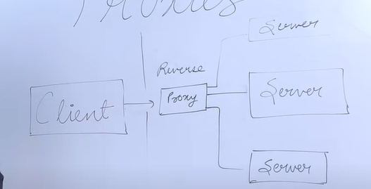

**Reverse Proxy –** Same proxy sits on server side acts as middle man for all server. Client talks to Proxy, Proxy server talks to all Server and gets response back to server.

In this case there is anonymity of servers, where client doesn’t know about IP of any servers, client only knows about the proxy.

**Why It’s useful?**  It can be useful for traffic controls, load balancing, caching response from server, Denial of services (DDos) attacks because servers are not exposed to the outside the world only proxy server expose to the outside the world, SSL/TLS encryption.

**Pros/Cons** - if proxy fails, it becomes reason for single point of failure or bottleneck.

**Proxy are important elements for** security, privacy, handling traffic.

**5.** **Data & Data Flow**

|  |  |
| --- | --- |
|  | For example of buildings, people are core entity, so people get into/out/stayin the building  Similarly, in computing systems data gets entered/manipulated or computed in the system and then served again back to the user  People can actually create the data and then access it, can actually just access the data and not create it , they can do both (youtube)  So data stays at the core of system design |

Let's understand how data is represented at different layers in different formats

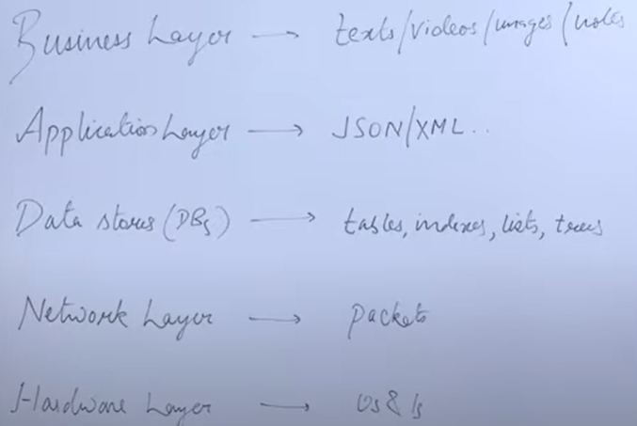

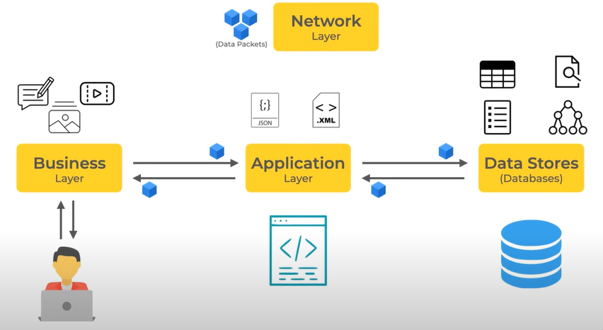

**1.Business layer or as a user** you interact with data in the format of text, videos, images, notes, etc

when the data travels to the 2.**application layer,** it is transformed in a different format like json xml etc,

when the data gets stored in **3.data stores or databases,** it gets stored in different data structures, which store the data effectively, ensure that the retrieval and the storage is efficient

Then at the **4.network** layer data gets transferred from one machine to another over the network in the form of packets

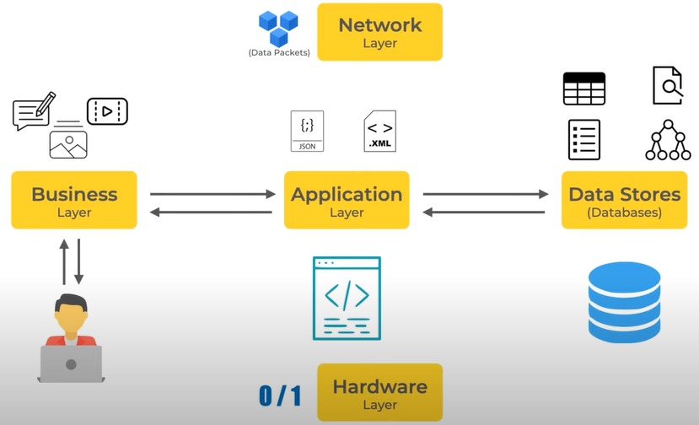

Finally at the hardware level, it's just zeros and ones

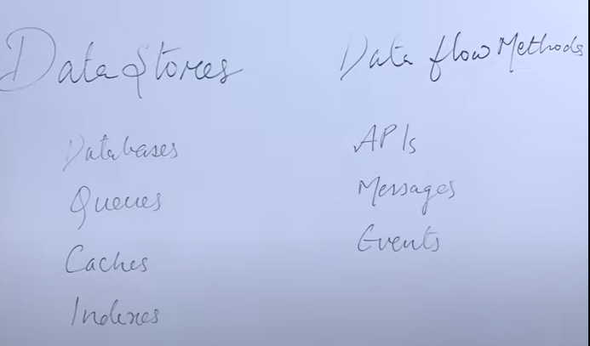

Now let's understand what are the **different data stores and the flows** through which this data flows inside the system

**why queues, caches and indexes are listed** Q has data in some format. Cache also has data which is easily retrievable rather than making a query to db, similarly for indexes data is stored in such a manner that it could be searched quickly

**Now how data flows among these data stores**. The data travel from app to db, from db to cache, from cache to app, from app to queue and then to db.

So the methods (**apis, messages, events, etc**) through which the data will flow ,which allow this data in different stores and the app to flow and get exchange between these components

|  |  |  |  |
| --- | --- | --- | --- |
|  | **Why this is important** because you need to understand when you have to store certain data in dbs, when you need queues/caches, which method you will use, so that the data flow becomes effective |  | **Now let's understand where does data come from or how the data is generated**  **Users** create the data or put input the data inside the system. Users will interact with the system and will create more data.  For example a notes or calendar app, e-commerce website.  **Internal data** when you have to store data about data or the logs of the application, which are running actually to serve the system, which systems populate on their own  **Insights** when users actually interact with the system and upload some kind of data or retrieve some kind of data some insights are generated  For example if the user is buying something from an ecommerce website, invoice will be Generated for that user. similarly if the user is interacting with a streaming system like youtube or netflix etc, there will be a history of what content they have watched, profile history, their payment/subscription details |

|  |  |
| --- | --- |
|  | **Understand the factors**  **Type of data - D**ata could be text, images, videos. A system which deals with videos and computing on those videos will be different from a system that deals with only text type of data.  It’s important because it will lead to decisions like which db going to use for storing videos vs for store some text.  **Volume of data**, a system which supports storage of terabytes of data would be completely different from a system which supports a storage of some gbs of data  **Consumption and retrieval of data,** some systems which are populating(writing) a lot of data and also consuming the same amount of data.  Systems which are writing a lot of data like even streaming systems but the consumption is not that high  Systems which are not writing that much data the system internally is populating a lot of information but the retrieval is high.  There could be both  **Volume** and reads and writes(**Consumption and retrieval)** these factors decide which kind of data store you will choose, which kind of storage strategy you will choose and what will your system look like for handling with such amount of data  **Security** there could be systems which are like transactional systems like banking etc, where the security of data is of utmost important  If it’s okay if you are not able to serve a request, if a user cannot log in a few minutes, but it is not okay that the data for that user gets leaked or compromised  Depending on these factors you will be able to **make informed decision on what kind of technology** you have to use in order to build a system that supports a certain volume and certain requirement for data |

|  |  |
| --- | --- |
|  | **Some examples of different systems which have different data and data flow requirements**  For example **an authorization system,** the volume of data might not be that high because it’s store some user and credential details, but the level of security is comparatively higher because make sure that the user credentials are safe whoever is requesting the access, we should not be given any wrong access to the resources  **Streaming systems,** the data volume is high and also the data retrieval speed, the number of requests that are coming to the system in order to retrieve the data (people are watching a lot of videos) has to be high. so here the data volume, the data retrieval is high. so streaming systems have to handle with both of those factors  **Transactional systems**, like banking systems or e-commerce websites, where you're placing in orders or interacting with a certain transaction, in those cases the journey of the transaction should not fail, it should not be done twice and the money in the bank should be intact, all those factors are really important.  for example if you have ordered for a headphones from amazon, if the data is compromised or something wrong with the processing of the data, you might end up getting a wrong order or not get your order  **heavy compute systems,**  so with the advance of ML and AI. for example systems which are dealing with the lot tons and tons of data, which is recorded by cameras & have to process over videos, have to use gpus in order to mine over the data and run sophisticated algorithms. the requirements of databases and the data storage are different because nobody is retrieving the data but a lot of data is being uploaded and being computed on these |

**6.** **Database types: SQL, NoSQL, Column, Search, Key Value**

|  |  |  |  |
| --- | --- | --- | --- |
|  | For example, the visual metaphor of buildings, if people are like data, then what could be databases, rooms in a hospital look different from rooms in a hotel, in a movie theater there are chairs lined up in front of the screen so that people can sit and watch a movie, in malls there are big large spaces so that people can move around  Similarly different databases depending on the property of data and the volume of data querying requirements provide different features and the way to store data |  | **some popular type of databases are relational, non-relational, file type dbs, network dbs, etc**  **Non-relational db's** are again divided into multiple types like **key value stores, column based dbs**, **document based db's, search db's**, etc |
|  | **Relational dbs** – 2 factors that help you decide whether you have to select a relational  db for your use case or not. 1. schema and 2. ACID properties |  | **Schema** - refers to how your data is going to be structured.  in relational dbs you have **tables and rows** which store the data  **A classic example, employees data** so you have an employees , department & account table.  Now this **id refers to the primary key or the unique id** which identifies every employee and department id and account id are **foreign keys** |
|  | the **department table, an account id,** now **how schema constraints come** into the picture  employee data will have requirement that one employee has to belong to a department and that employee has to have an account as well so department and account cannot be null, that is a schema constraint |  | **what are the benefits of this relational dbs or schema**  Can represent complex data easily using relational tables  With the schema constraints, you can ensure that garbage data or null data doesn't get into your database because the schema constraint like department id cannot be null |
|  | **ACID Properties (Basic explained)**  **A (atomicity)**  means a transaction in a db either happens completely or doesn't happen at all  For example if you have to transfer money from one account to another account, the transaction should deduct money from one account and put money into the another account, but it should not happen that it deducted from one account and didn't update into the another account.  so that is breaking the rule of atomicity relational db's ensure that all the transactions are atomic either they happen completely or they don't happen at all |  | **Consistency** means that at any given point of time the state of the db will be consistent. It will not happen that if two reads (requests) are trying to read the account balance, one request gets the response as 500 and another gets the response as 400.  This is not possible if the db supports ACID properties because your db is consistent it will give the same value to both the request |
|  | **Isolation** means the two transactions do not know about each other.  For example there is a read happening on the balance and at the same time there is a write is also happening, when read will read the older value like 500 until the write is completed and write will go and update that value to 600.  if the read happens after right it will get 600, if the read happens before right it will get 500.  Read would not know about the right operation |  |  |

**Durability** is a mechanism that database ensures whatever writes or updates are happening, they are logged properly and all the details and the data is getting persisted into the disk storage

**Support Relational DB -** if you have the need for transactions (like a banking app), if you have a fixed schema. Not going to change schema in future as mush, then select Relation Dbs

**Does not support - a** certain kind of data in which this **schema is not fixed**, you do not know what are the different columns or fields, so in this case using relational dbs becomes a little difficult.

When the **table size grows and the data set becomes huge** it becomes increasingly complex to add new columns

When the **data size grows and the queries require multiple properties** to be fetched from different tables the joins can become expensive

1.In this case when relational dbs **don't have show much performance**

|  |  |
| --- | --- |
|  | 2.**scaling** - it is easy to store or scale vertically, **vertical scaling** means you can increase the storage of one machine, so suppose if you have a table that has say 1 million rows when you foresee that it is going to grow to 2 million rows you can increase the memory of that machine  but in case of relational dbs it becomes difficult to divide that table and put it on two different machines there are ways to divide the table through application code, but it is difficult to perform horizontal scaling |

**Non Relation dbs (NoSql)** - the schema is not fixed.

**Key Value stores -** like a hash map, it will a key and a value. key value stores like caching solutions are implemented using redis, dynamodb, memcache. **Benefit** is they are quite fast and quick access because most of the data stores are in memory

Data like application related data or configuration related data, request response into key value stores

|  |  |
| --- | --- |
| A picture containing timeline  Description automatically generated  Example relational db compare to document db | **Document based databases** used when you are not sure of the schema or how the data and the fields different fields of data are going to involve over time.  So there is no fixed schema, they can support heavy reads and writes  When querying data you would need all these properties in one query, so you don't want to have this different data in different tables and then make joins and fetch the data  so documentdbs help you in decreasing that complexity where you can just simply fetch documents from the database  so when you have use cases like that the schema is not fixed, you don't know how it is going to evolve over time, you want that flexibility of keeping dynamic data and also when you have the use cases for heavy reads and writes in such cases document dbs are a choice    **Downsides** - 1. you don't have schema, 2. you might have null values or empty values in your db, 3. these type of dbs do not provide ACID transactions (handle through application code)  **Summarize some of the benefits**- 1. highly scalable 2. sharding capabilities 3. dynamic data flexibility 4. Special querying operations (aggregation) |

**Column dbs or column wide stores** - sort of a midway of relational dbs and document dbs, in a way that there is sort of a fixed schema with tables and columns but these dbs do not support the ACID transactions.

**Used** when you have a requirement of heavy reads (like event or streaming data).

so if you use a music app, you are continuously either liking the song, skipping over the song, favoriting your song, all those interactions that are doing have to be written and stored in dbs as event data, so that analytics could be run over them, such kind of data is stored in column dbs

Other examples could be storing health tracking data or storing data for IOT devices, where different sensors are deployed and sensors are sending data continuously within every 10 seconds or 30 seconds in all such use cases column dbs are used

because they support a large number of heavy writes, coming to the reads such dbs do not support huge number of reads but they do support special kind of reads and the table structure is defined by the kind of queries you have to make

For example, the music app the queries will be you have to fetch user detail, song detail, fetch users that have liked a particular song, fetch the songs that are liked by a particular user. so some tables in column db could be then users, songs, users by liked songs and songs by users with respect to what kind of reads are required

column dbs are a good supporter of **distributed databases**

popular examples of column dbs are **Cassandra, hbase, Scylla**

**Search databases** where you search for something like booking a flight or a movie or purchasing an item on amazon all those full text search queries are supported by data stored in search databases

For example **Reverse Index**, similarly the data against those queries is stored in advanced indexes inside search databases so when you search for a particular item say “vin number”, there will be data saved in these indexes. Examples of such databases are **elastic, solar** etc

The important thing to note here, the data stored in search dbs is **not the primary data store**.

An **e-commerce application**, the product & catalog entity. All the products and items will be stored in a primary database maybe a relational or a non-relational db. And the **results of search queries are the data**, on which frequent queries are executed that will be stored on search db and **it will be refreshed** as per the frequency of the queries

Other **dbs use cases** - 1. data are images and videos, such a kind of data is stored usually on cloud in amazon s3 or buckets (google). 2. large data sets or time series data where a lot of data has to be stored and analytics is run over that

**Graph Databases** show the connections between different data points. They are used to analyze different types of data and their relationship with each other. These are represented in the form of a network of objects or nodes that are related. Examples are the Datastax Enterprise Graph and Neo4J.

**7.** **Applications or Services**

|  |  |  |  |
| --- | --- | --- | --- |
|  | All such functionalities in the building are separate application used to build the system.  **For example**, Services or functionalities existing in the building – elevator, water supply, electric supply  **Take the Client <-> Server architecture**, Piece of code that is running on the client and server side code, which is delivering a certain responsibility or tasks while catering needs of users/system requirements.    **Applications or services** performed or fulfill certain responsibilities/tasks |  | **Tech Stack**    2 things **languages and framework**. Language – you can write whole applications on your own, framework (spring book, larval,..)– doing most of bootstrapping, common task that a need for application, use the framework  method of communication between application or api **are l**anguage **agnostic, it doesn’t matter wh**at are 2 application interact with each other. |
| **Backend App Common Responsibilities**   * expose api endpoint * implementing business logic * Handles data modeling or data transformation * Interact with data stores * Interact with other services | **Client App Common Responsibilities**   * Render UI element - * Handling interactions – click post button, fetch particular video, watch video * Collect Data from user * Communicate with backend to fetch/store data * Render static data |  | **Elements /Factors of App Design/Development**  Design parking lot –  Layer – mobile, web, client  Follow the best industry standards. |
|  |  |  |  |

**8.****API**

**Application** – have to interact with each other through API

**Programming** – Through API one piece code is able to interact with another pice code which can be running same machine or another machine, same language or another language) through programmatically. Through code what can mention what you want from API (send, fetch or computation).

**Interface** – abstraction , one piece of code running on machine 1 and other piece of code running machine 2 through api, this code would know what api to call , but it wouldn’t know how the other code doing.

**Advantage –**

**Communication** – 2 different application interact each other

**Abstraction** – api provide you way freedom of implementation – for example, Instagram api , this api called “get followers” called, you get the response 2k. the implementation of “get followers” can change any time (bugs or some improvements) but called won’t change.

**Platform Agnostic** – one is written in java and another is python, so different language or platform can easily interact.

**Examples**

**Private API** - are hidden API, only an application running in your device or phone has access to, not available to public, for example any app inside your phone which making payment request

**Publi API** – goole maps, weather, facebook developer api

**Web API** – superset of private or public, web api means application which are running on cloud can interact with each other, for example get followers, list followers Instagram, post photo

**SDK/Library aPI** – for example using threading library, which expose functions like lock, release lock, fork, join methods which are going to use in your code. Again advantage is **abstraction**. Underlying implementation can change but your code can’t change.

Useful Links:

<https://stripe.com/docs/api>

<https://www.mulesoft.com/resources/api/what-is-an-api>

<https://www.redhat.com/en/topics/api>

**Factors**

API Contracts – end points, send data particular format

Documentation – public available

Data format – how it’s going to exchange

Security – you are exposing

**Standards**

RPC

SOAP

REST

**9.** **Caching**

|  |  |  |  |
| --- | --- | --- | --- |
|  | **What is cache – Simple concept of cache**  for example, you are asking your room mate what is square of 75 => answer is 5625, he took few seconds to reply the answer. In the evening you are asking same question, you will not calculate the answer, directly say 5625, because the answer you calculated in the morning is **now cached in the working memory of brain**  **in computing world** also cache defined as hardware or software components which helps in serving the data which is either frequently request or expense to compute on, so cache stores the computer response and helps in saving the computer operation. |  | **Example 1**  Client ->Request image from -> Server -> fetch the image from disk  <- response => this takes time  Now same or other client, -> requesting for same image -> fetching every time image from the disk is expensive operation  **What can be done**, either 1) save copy of the image in the server side, this can be done on reverse proxy server or 2) cache of the in the client side (example could be browser cache). |
|  | **Another example** , client -> request -> server ->fetch -> database -> server performs some computation -> response back to client  If same request comes again after some time, again server ->fetch -> database -> server performs some computation. It’s **redundant**  Get redundant operation by just saving response and request in a cache.  Next time if request comes, the sever or application layer checks if it’s available in the cache and then serves the response (it’s called **Cache hit**)  If no cache available, then server fetch the data from db, stores in a cache (it’s called **Cache miss**) |  |  |

**Cache Invalidation & Eviction**

Data kept in cache is not there forever, it’s is volatie, that means the **data in someway invalidate or removed** from the cache

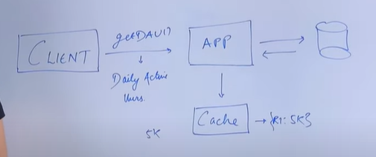

**Cache invalidation is needed** because the data that keep in the cache is going to change some point of time & if the data is changing you have to update the cache and process of updating the cache that’s removing old value or updating new value is called **Cache Invalidation**

**Ex, Client ->request “getuser”** -> app -> db -> app ( assume count is 5k) -> cache (5k) -> back to client.

**If same request comes after 2 hours,** you can’t give 5k, because by the time no of user increase -> so you have remove the data from cache and fill up the fresh data from db (it’s called **warming up** or filling the fresh data).

**How do you decide when we have to remove or invalidate the data? Methods are**

1. Keep an expiry time (it’s called **Cache expiry**), it’s done through method called **TTL (Time to Live)** . you mention at time like few hour, min, seconds when this data will be expiry.
   1. **Example:** set expiry time 10 min, what does it means, this means suppose **Request1** comes time t0 , the value 5k will be return. Request2 comes time t8, same value will be return. Request3 comes time12, more than 10 minutes passed, this value will be removed, because it expired because of TTL. In this case server has to go , query the db and fill the cache and give the response
   2. **Suppose if we set low time like 60 seconds**, lot of request will come and value will expiry very fast and lot of request to db and computation will happen, we **can’t really using the power of cache.**
   3. **Suppose if we set longer time**, like 48 hurs, the people will get same data (5k), because no of users definitely increased. So we don’t want this issue.
   4. **So really hard to determine** how much time should kept for expiring cache or invalidate the cache. **It’s not determinizing the problem?**
   5. **How do I solve? It’s solved depending on the use case** 1. You can **tell user this number** get update once during a day or twice during a day.
2. **Other method the invalidate the cache other than expiry,** when the user count change **1.application** will remove the cache, when “getuser” request comes in, it go fetch the db and update the cache also, because it’s cache miss happens. **2) application** will update the db, it also update the cache.
3. Some time you can **use combination of methods**.
4. It’s depend upon the **caching pattern you use**

**Cache eviction - What happens even after the setting an expiry** there are lot of number keys available in the cache.

For example, every cache solution **has limit to the number of kyes to store**, suppose 1000 keys, what happens **when new key has to update**, in this case any of existing key **has to be evicted**, so that room for new key could be made , this is callee **cache eviction**. There are lot methods

1. **FIFO (First in First Out)-** key that has been written to the cache for the very first time will be remove (k1 – v1, k2 – v2, k3- v3 … kn - vn), suppose k3 written the very first all are came after that, k3 will be **evicted**.
2. **LRU (Least Recently used) -** (k1 – v1 access 1 min, k2 – v2->2m, k3- v3, k4- v4->5d, k5- v5->1h … , in this case k4 will be evicted.
3. **LFU (Least Frequently Used) -** (k1 – v1 access 100 times, k2 – v2->200t, k3- v3 -> 5, k4- v4->10…), in this case k3 will be evicted.

**Cache Pattern**

**1. Cache aside Pattern** – When request to app, app check the cache, if cache available it returns. Otherwise app fetch data from db and update the cache & return back to Client. So in this cache kept away, application talks to cache, **cache never talks to db**. **When does the problem happens?** The new value updated in the db, in this case , the cache has to be invalidate, either using TTL or app update the value same time db update. **Advantage**, if cache downs, still app get the data from db, but large number request to db. **System would not fail, it may slow down**. **Disadvantage – decide** whether long expiry or add the code in the app.

**2. Read through Cache or Pattern** – App talks only to cache, never to db. When first request come, there always cache miss, then it fetch the db , update the cache and return the resuslt  **Advantage – for heavy read (news feed). Disadvantage** – first time get the data from db & fill the cache. **It can be solved by pre heating cach**e or known in advance what is the request is going to be or what kind of data before first request.

**Difference between 1 & 2.**

**1 app talking to db & 2 cache talking to db**

**1 not similar, data modling in app | 2** Cache can be implemented by 3rd party or libry and data modeling between cache and db has to be similar.

**2. Write through Cache or Pattern** – what happens When new data has to be written in db? There is no difference between Read pattern. In practical app both are used together. App will read/write to the cache and cache write/fetch to db.

**3. Write around Cache or Pattern** –overcome, app directly talk the db for writes. For reads through cache. In this case app talking to db and cache it’s goo for when lot of writes.

**3. Write back Cache or Pattern** – app kept in cache, after some time all those writes in bulk send to db (batcing). It’s useful for lot of writing & can handle db failure. Downtime if cache down, loose write down. Example log, journel.

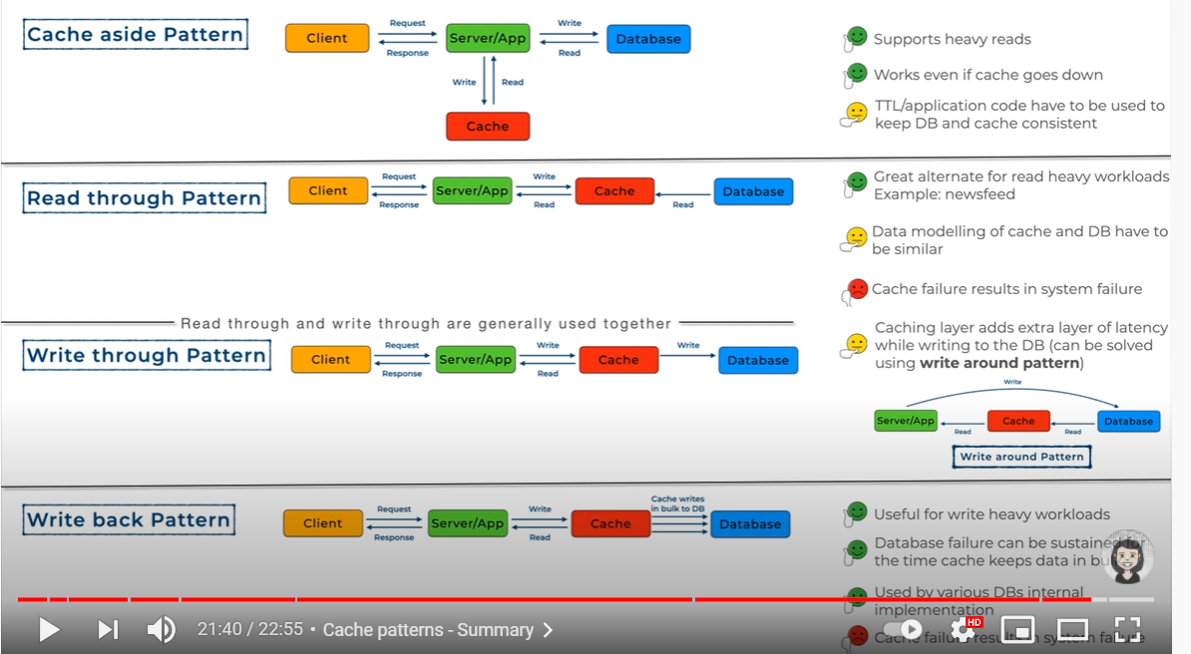 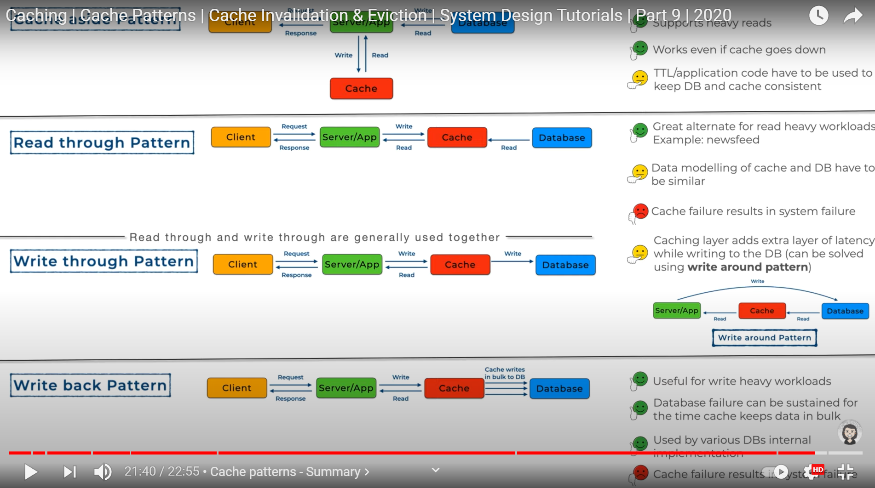

**Where do I keep my cache? Can be kept in any level.**

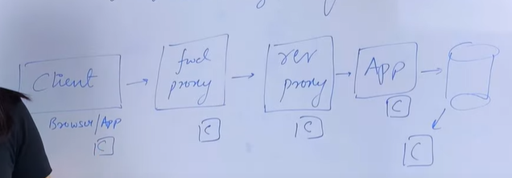

**10.** **Rest API**

What is **REST (Representational State Transfer)** . RESTa ctually **defined 5 or 6 guidelines** that have to be follow on client and server architecture for the data to be exchange between client and server. State means for example first time client request, return 4 user records from db (now state contains 4). Now db updated, so next time, returns to 5 records. (now state contains 5).

**Guidelines of REST**

1. **Client & Server architecture** – transferring data
2. **Cacheable** – data from server is cachable or not, if cachable, ui read from cache.
3. **Layered** – RESTAPI communicating with each other know immediate layer for example, client –> server -> database. Client knows server would’t not about db.
4. **Stateless** – very important ,one server will get request from multiple clients. One server will get same request from same client also multiple times. Server never save, both are same if c1 sends request or c2 sends request. Server/client never save the state any where. Serer treat all clients uniform manner. So it’s statless

Some apis which might need to store state like authorization, it’s special case

1. **Uniform interface** - whenever any data is being requested/modified from client to server, that interface do should always uniform (like one api is implemented http and and other api is implemented different protocol). It should always follow same protocol, contract, rule
2. **Code on demand** – little advance, it’s optional, means that a server can send code to client that is should execute on runtime (like java applets or javascript)

**Examples of REST API**



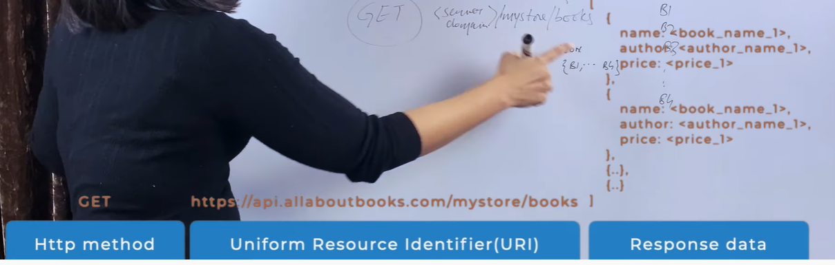 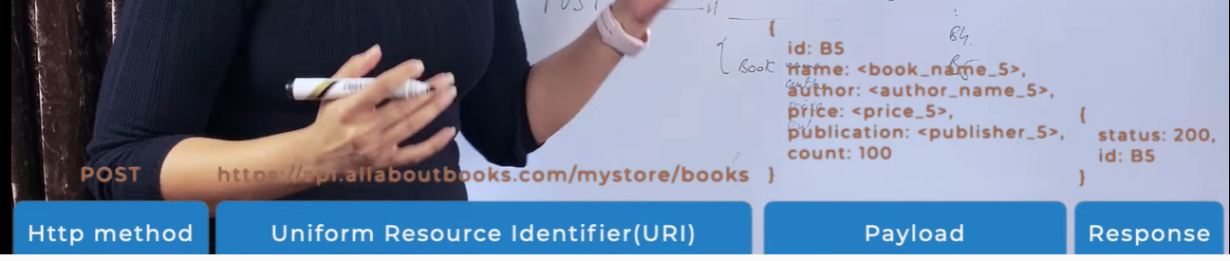

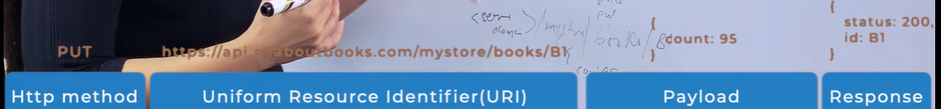 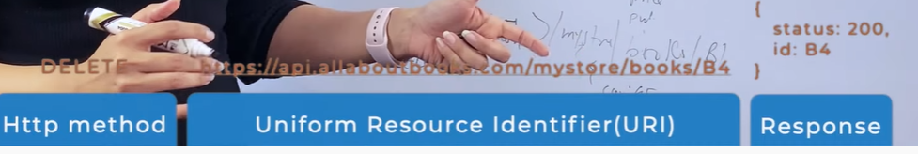

**State Transfer vs Stateless**

**State Transfer**

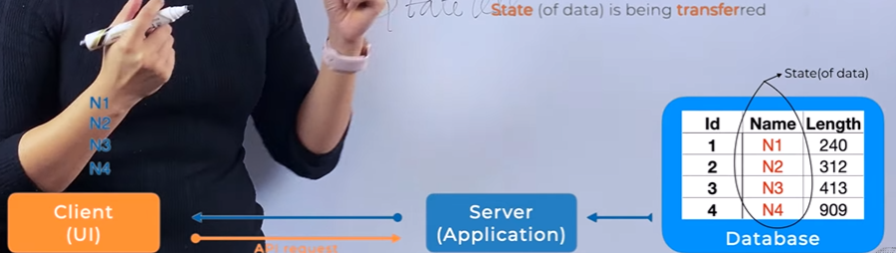

**Stateless**

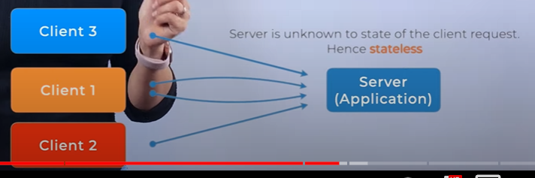

**Path & Query Parameters**

**Path URI ->** <Sererdomain>/mystore/books/id -> id is path parameter, looking of only one book

**Query URI ->** <Sererdomain>/mystore/books?limit=20&offset=0 ->looking for all books return only 20 but start from 0, limit=20&offset=21 starts from 21

**HTTP Response (Status Codes)**

**2xx – success** => 200 – OK, 201 – created, it contains id.

**3xx – Redirection** => 301, 302

**4xx- Client** Error => 400 badrequest, 409 conflict, already exist, 412 data not readable

**5xx – server error =>**

**Security, Authorization and Error Handling**

**How to use headers in REST APIs? Different types of headers, how and where to use?**

**types of headers - key value pairs**

|  |  |  |  |
| --- | --- | --- | --- |
| **request header - sent by the client who is requesting for the data. So that server can understand how the server has to send the response and also can get some knowledge about the requesting body or the client.**  **note that content type is not a request header content type is categorized as one of the representation headers**  **the user agent or the host are holding the information that who is sending this request**  **Accept language - telling server that this is the language i'm going to understand the response**  **Accept encoding - send me compressed data** |  | **Response headers - where server is telling the client who is requesting for some information that what to do with response**  **e-tag is one of the important, used for versioning and cache** |  |
| **representation header - the data that has been transferred from one server to another can be in different formats ( xml, json, encoded). it can be sent as one piece of data at a time or chunked**  **content location - alternate location of the resource or the data that is available for the client to retrieve the information** |  | **Other different headers like trailer:expires, transfer-encoding:gzip, etag:w/*8015*, if-none-match:*, authorization:…,**  **Define your own custom headers – yes** |  |

**11.** **Message Queues**

**Synchronous vs asynchronous communication**

**Synchronous –** whenever you get the phone call, you pick up the call, person on other side talks to you and you response. Both parities are connected with each other over a dedicated line and a responding to each other or exchange messaging in a synchrous manner. No wait time.

**Asynchronous** – you get a message or email, you don’t reply to all of them as soon you received. Send response after some time. Also the person who’s sending you message/email is not expecting message spontaneously. It’s not urgent.

Same apply to both components. Like client send to server.

**Real world example** - In **Bank**, there are **teller** windows (t1, t2, t3), If all are **empty**, you can just walk up to and do transactions. If all are **Synchronous**, **queue** comes into the picture( you go stand on t1 or t2 or t3 queue) or you go to **token** counter, get the token , when token flash, you go to the counter. You are **not getting service immediately** but you are being put on queue or token, you are communication /transaction are happing, but it’s happing with queue.

In **System**, you want to request all your past 6 month invoices,1) this operation will take some times (couple of seconds), they can’t expect to wait for 4 or 5 seconds. 2) this could be multiple request (100 or 1000). **See the image Request invoce -> online store -> c1/8, c2/4mon, c3/1 (queue) -> invoice processing component -> email**. This is **Asynchronous using queue.** Benefits – 1) customer can’t wait 2) online sore can handle larger request.

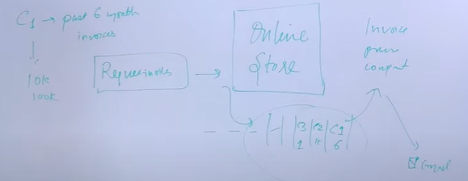

This is **queue** ( c1/8, c2/4mon, c3/1), what does it have, it has **messages**. When you have **Lining of messages between 2 components** (online store and invoice processing) to talk each other. This is called **Message queue**

**Message Queues (Producer and Consumer)**

**What could be queue –** it could be process which has a **data structure in memory** to store messages, it could be process running on the **same machine** as the component with are interacting queue, it could be process running on the **different machine** and the components have to interact with different machine

**Example –** Kafka , RabbitMQ – complex queue

It **consists** of messages (are short size data, what has to be done).

What are **the components that talk to queue** – **Producer** ( are the component which tell what has to be done). **Consumer** (are the component which carry out the particular operations).

**Invoice generation** example, **producer** will put the message into the queue (this is the customer and generate invoice for 6 month). **Consumer** will pick up the message and do processing.

**Advantage –** 1)can **handle lot of request/load** (Decouple the load )(consumer keep pushing the request into the queue and Consumer can keep process). If no queue, system can’t load.

2) **the consumer can be scale**, if lot of request, you can increase the consumer (example teller)

3) if consumer stops work or some issue with the component. **The message remaining in the queue. Actual process or data neve lost**

**Ordering and Consumption -Important concept**

**Consumption** – that’s one to one, (message pushed by the producer in the queue will be consumed or processed only one. Once it consumer consumed the message it’ remove from the queue. **c1 (consumer) process m1 (message), it will acknowledged to the queue, queue will remove**.

**Ordering –** decide which message to be order or not. Chat app – order is matter. Invoice example – order doesn’t matter

|  |  |
| --- | --- |
| **Order queue example – 1)** FIFO (first in first out), Amz SQS uses FIFO ordered queue.  There are messages like m1, m2, m3, m4, **only one consumer (c1).** When m1 consumed from c1, it’s removed from the queue, then m2 , m3 & m4 consumed. This order of consumption.  Now wht happens if there is m5, m6 & consumption of m5 fails. What happen queue will block ther operation here (m5), it will not let consumer pick the other msgs until m5 process. So Processing will stop, m6 can’t process.  2)Suppose There are messages like m1, m2, m3, m4,m5,m6,m7 multiple consumer (**c1, c2, c3, c4).**  **C1 takes m1 will remove**, c2 takes m2, c3 takes m3, c4 takes m4. Now c1 takes m5, c1 fails to process. So consumption will stop m5 here until m5 is consumed either c1 or c2. This is **downside** of FIFO ordered queue | **unOrder queue example –** There are messages like m1, m2, m3, m4, **only one consumer (c1).** When m1 & m2 consumed , **m3 fails**, m3 will be push to **retry or fail queue or AMZ SQS dead later queue** & will be remove from the queue. Now c1 tak3 m4 and m5,… Msg consumed in the order of m1, m2, m4, m5, m3.  2)Suppose There are messages like m1, m2, m3, m4,m5,m6,m7 multiple consumer (**c1, c2, c3, c4).**  **C1 takes m1,** c2 takes m2, c3 takes m3, c4 takes m4 **it fails**. M4 will be push to **retry. C4 pick m5, c5 may be pick m4.** |

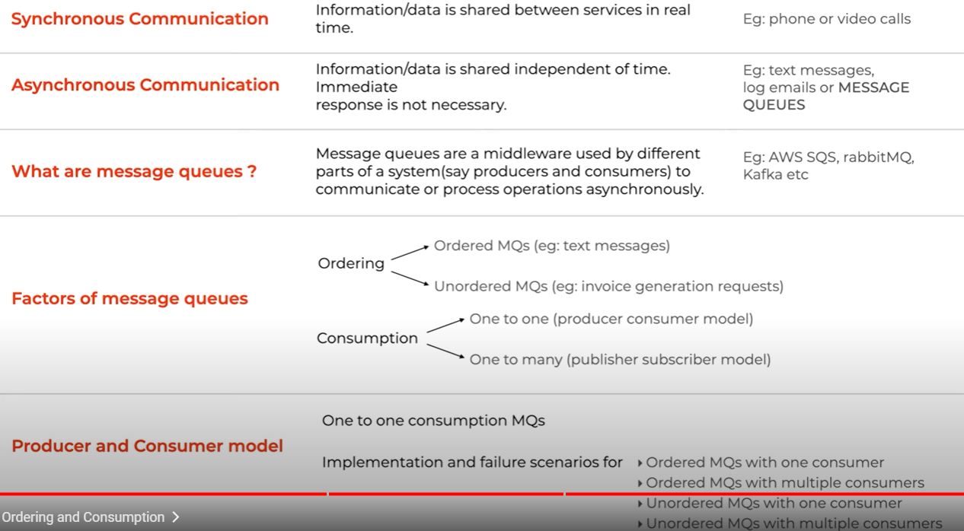

**12.** **Pub Sub Messaging**

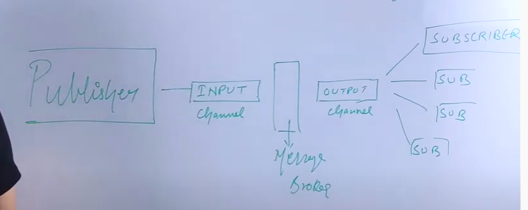

1. **Publisher** publish the message, 2**) input channel** is where publisher going to send message, it would be architecturally physical component, which is going to store the event or msg 3)**message broker** which takes care of multiple responsibilities, publish msg has to be modified & divide msgs into different topics 4) **output channel**, 5) **subscriber or consumer** who want to react those msg subscribed to, they subscribed the output channel. There can be multiple output channels for multiple subscriber, **for example** subscriber1 wants to react only particular kind msg not all msgs. If every subscriber react to every msg by publisher we will **not able to scale the system and not good performance**, real world scenarios also it won’t be to possible that the subscribe have to listen every msg, it’s nosiy. So there can be different output channel

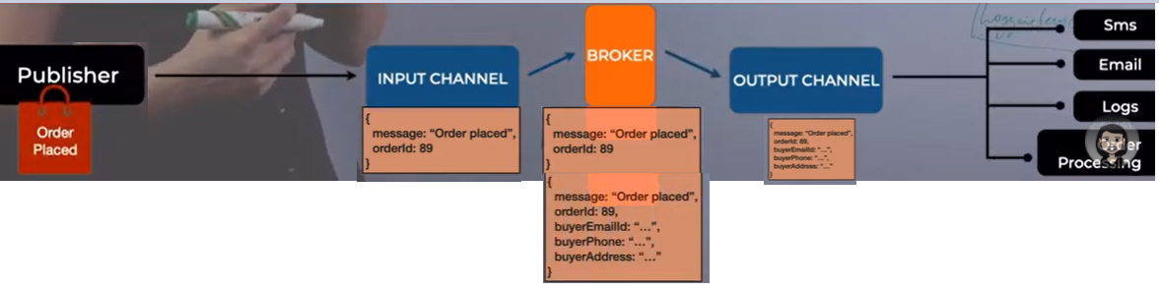

1. The order get placed, 2. publisher can send the message order placed and order id, 3. what broker will do, it might be possible that broker has take the order id and and more details (like, fetch more details related to order (what time, when , who created)) 4

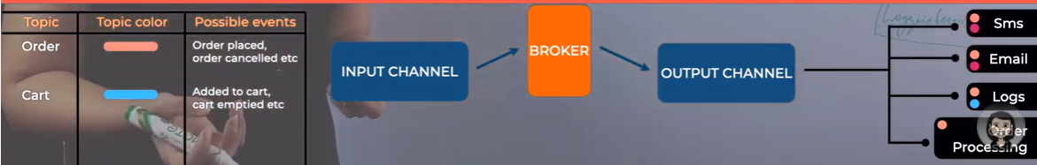

The order is placed one event, like move event placed. All these events divided into topics (order related, cart related topics created).

Publishers create and send messages to a topic . Subscribers create a subscription to a topic to receive messages from it.

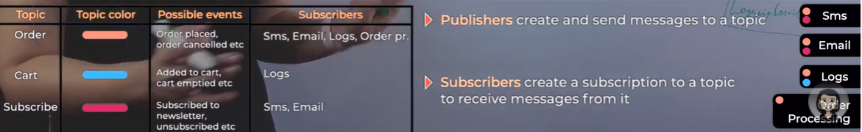

**1.**Decoupled component 2. do not depend on each one another. 3 Can be scalable. Distributed systems.

**Factors of Pub/Sub Messaging**

1 Message ordering – No, if you want ordering there is a priority queue pattern , other wise take it through application

2 Message consumption – one to one module

3 Discard Messages – Malform, wrong

4 Duplicate message

**Pub/Sub Use cases**

**1 Async Workflow – Place order example**

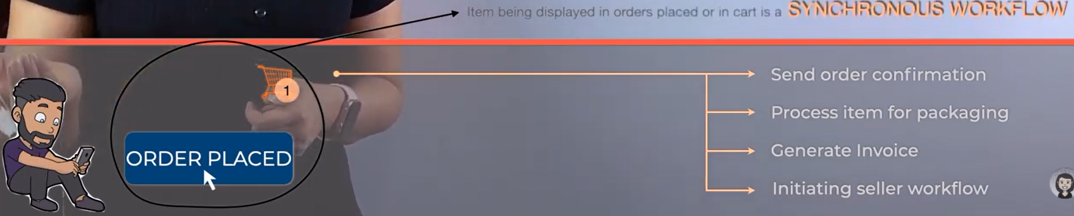 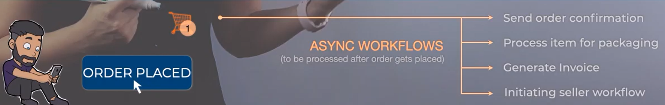

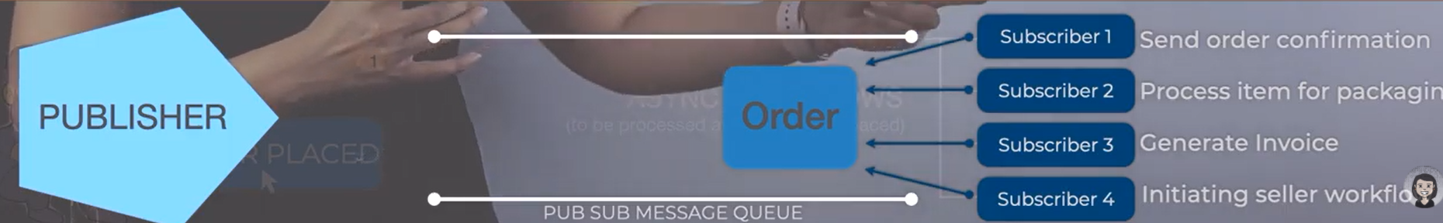

**2.Decoupling**

 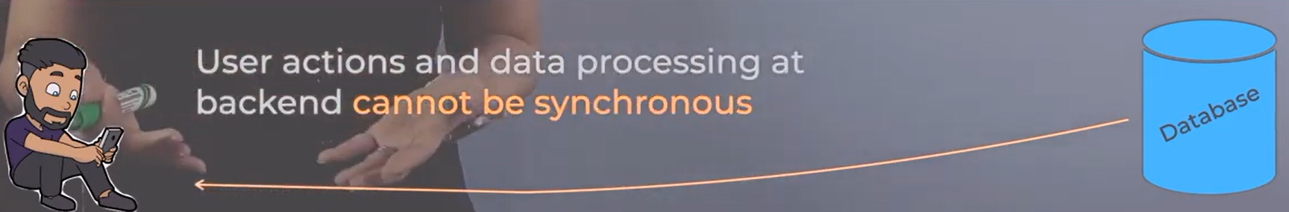

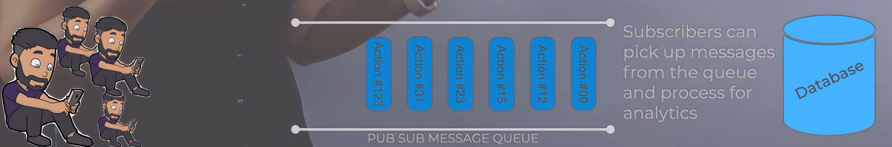

**3.Load Balancing**

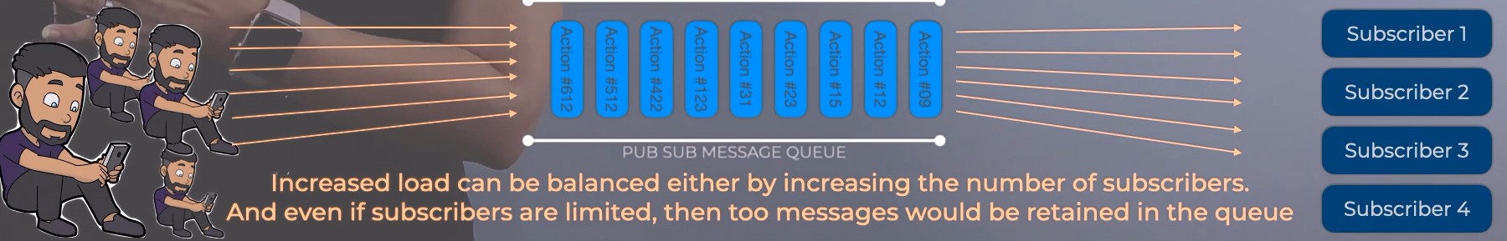

**4.Deferred Processing – Deferred means do it later or back log**

**5.Data Streaming – Iot or sensor, camera sending date continuously**

**When you should not use –** 1 you have 100 customers, 60 orders coming every day. You don’t have to implement this architecute. For small requirements, don’t kill no need big scale. 2 Real time system , response available immediately. 3. Asynch message need some acknowledgement, publisher send msg ,need some acknowledgement.

**13.** **Performance Metrics**

**1.Throughput:** can be understood as some amount of work done in a particular time, so the concept is

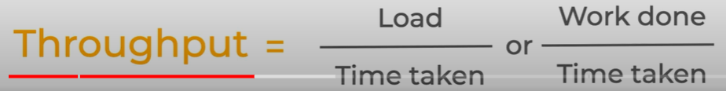

**For example**, A able to chop 20 onions in 1 hr this is A throughput, if new/no experience B can able to chop 10 onions in 1 hr this is B throughput. so A double the throughput, produce more output of work.

**Example**: A 4-lane road, Fruits have to be transported from a to b. 1 vehicle truck which can transport 100 kg within an hour. Suppose 400 kgs have to be transported

|  |  |
| --- | --- |
|  |  |
| Case 1 | Case 2 |

**Case 1**: if every truck travels on different lanes then within an hour 400 kgs could be transferred so the throughput 400 kg because of this 4 lane system of the transportation.

**Case 2**: last 2 lanes are reserved, both the trucks t3, t4 travels on l1, l2, so all 4 trucks do not reach within an hour, may take like 1.5 hour. So the throughput would be low bcaz in hour not able to transport 400.

**How can the throughput of the system could be increased?**

|  |  |
| --- | --- |
| **way 1** | Way 2 |

**way** 1: increase the truck capacity (carry 200 kg), in 1 hr transporting 800 kgs, so throughput doubled

**way 2**: use 8 smaller truck (carry 100 kg), hypothetically in .30 min, the throughput has increased bcaz 800 kgs transferred within .30 min so the throughput has doubled in hour it will be 1600 kgs

|  |  |
| --- | --- |
|  | Scaled system |

**In system design** throughput is how many api calls are being served in a particular amount of time

**for example**, a system which handles **100 orders within 30 min**, so the throughput of the api or system is 100 orders. A well scaled system can handle 1000 orders within 30 min so the throughput is 1000.

**2. Bandwidth:** comes into play with data getting transferred over/ connected networks on multiple locations

For Example, netflix bandwidth is of huge importance because streaming has to happen over different locations simultaneously, so the amount of bandwidth those machines have which can deliver and serve the data at such a high speed in such a small time almost in real time

**what is bandwidth**: a certain network bandwidth only certain amount of data (like 100 mb or 1000 mbs or 2gb or ngbs) can be transferred over a given network.

|  |  |
| --- | --- |
| 2 trucks transporting 100 kgs, 2 lanes can transfer 200 kgs per hour   | 4 trucks can transport 400 kgs per hour   |
|  | 4 trucks, t3/t4 would have to wait, in this case supply a higher throughput like 400 kgs in hour but the bandwidth is restricting, so throughput is 200 kgs per hour. because you are constrained by the bandwidth |

|  |  |
| --- | --- |
|  | Point is 1) higher bandwidth and you have resources for to utilize that higher bandwidth and transport the data you can have a higher throughput |
|  | 2 if you have the resources to transport the data but the bandwidth is low then your throughput will be blocked or maxed out by bandwidth |
|  | 3 higher bandwidth, 4 lanes, only 2 trucks, throughput will be maxed out at 2 trucks 200 kgs per hour because you do not have more trucks to flow |

|  |  |
| --- | --- |
|  | not enough resources + higher bandwidth => system will perform  enough resources + lower bandwidth => system will perform less  enough resources + higher bandwidth => a very highly maximized performance |

**3 Response Time :**

|  |  |
| --- | --- |
|  | System is able to serve a 1000 request/ second ( 1 second able to serve 1000 request)  For example, sent a request at t1 second & got the response at t2 second, got the response within 1 second (this is the response time of your api). |

1 gbps of bandwidth, the system's throughput is 1000 request/ second the data that is being transferred, this is optimized like this network's capacities utilize the bandwidth

Suppose your api slows down instead of taking 1 second it takes 2 seconds, you have bandwidth & multiple request but your requests are taking time to respond, in this case you might not be able to support 1000 request in a second because your request itself is taking 2 seconds

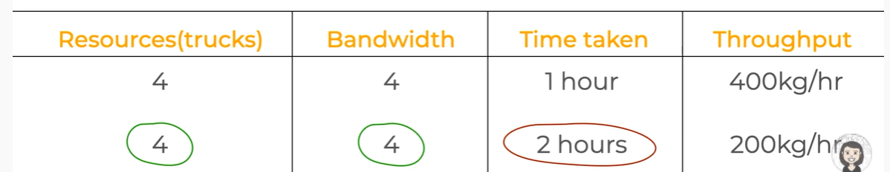

Case 1: 4 lanes, 4 trucks, every lane can have one truck at a time, throughput is 400 kgs per hour, bcaz truck can travel in hour, it has that much speed

Case 2: heavier trucks, wrong with the truck or parts or old or the driver or the speed, whatever the truck cannot travel at a speed to reach within an hour instead it takes 2 hours to reach and delivered 400 kgs, so throughput 200 kgs. what happens when you have the bandwidth & resources to provide throughput but your response time

**14.** **Performance Metrics of components in a software**

**1 Application:** (Front/Back end, business logic, data transformation) , the following metrics is measured how it’s performing.

Application supports CRUD API, how the code is performing, how much time it’s taken by the code running in the application to CRUD.

**Metric 1 Response Time**: how much time this APIs responding for this particular application.

**Metric 2 Throughput of APIs**: a given amount of time, how many APIs can one application support.

If it’s good performance code, ideally it will take some milli seconds to fulfil a basic call to the database , fetch the data, make some changed and return the response.

**Metric 3 Error occurrence:** how much error it’s producing, if code is not handled certain edge case or scenario, if logs system shows lot of errors, measured to decide the performance of app degrading.

**Metrics 4 Bug/Defect in the code:** how many bugs does it have? What happens if particular input actually make your application to crash, if that happens that means application is not resilient

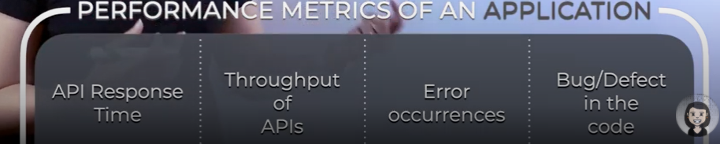

**2 Database:** how do we measured the performance of the database.

**Metric 1 Time taken by various database queries**: if good or performance queries, index placed, design the scheme, ideally the query won’t take lot of time. If you have huge data, query might run slow.

**Metric 2 Number of queries executed per unit time (or throughput)**: how many no of queries db can support? How much time it’s taking, throughput of queries , db supports huge number of reads and writes without any degression - conclude db performance is fine.

**3 Cache:** Cache is in-memory key value store & fetching data from cache is quick

**Metric 1 Latency of writing to cache**: when the entries are writing, if latency is high, then we can tell it’s not performance well because writing take time. Reading cache won’t take much time,

**Metric 2 Number of cache eviction and invalidation**: Whenever new keys are written to cache & eviction or invalidation is happening at good rate or high, then it performance.

**Metric 2 Memory of cache instance**: Lesser memory and more keys are added, increase memory size. Eviction or invalidation strategy is not great, then decrease the cache eviction time so that writing loads can support by cache.

Throughput is here, how many queries can be written or how fast eviction happen in a given point time to performance the metrics

**4 Message Queues**

**Metric 1 Rate of production and consumption**: speed with push/pull the queue, establish the system processing 5000 megs/min, that throughput will give idea how much performance of the message queue

**Metric 2 Fraction of stale or unprocessed messages**: Bad msg, msg failing, consumers not processing msg, lot of msg in the failed queue & retry – if it happens, your throughput will go down.

**Metric 2 Number of consumers affects bandwidth and throughput:** if you have multiple consumers, 10000 msg, msg will consumed faster and throughput is higher. But in other hands, less consumers & more msg, take lot of time to process, so throughput is low. We need to balance. If increase consumers and less msg, then it cost more

**5 Workers :**  some independent workers are running inside or separate the applications. Use cases are consumers picking the message, workers running schedule to pull some data

**Metric 1 Time taken for job completion**:

**Metric 2 Resources used in processing**:

**6 Server Instances:**  All components need some hardware/infrastructure (cloud or on premise) & running on some instances. Every components in itself some requirements, 2 basic requirements : Memory I RAM & CPU.

**Metrics 1 Application performance consideration**: Application need RAM not memory. But if complex application (lot of computation) may require CPU. If code has memory leaks, lot of errors, computation are heavy, so RAM or cpu go high

**Metrics 2 how many Resources consuming**: If code is right, but requirements is high, then change bigger or upgrade instance. Other hand code is nor performed well (like memory leaks, lot of errors), it will eat cost. So in this case refactor the code

**Metrics 3 DB performance consideration**: DB need more memory and CPU (like reading, writing, logging. it would need CPU). Long query, data set is huge, in this case CPU will spike.

If lot of data is coming, suppose to delete old data, if it does not delete, then memory usage will go high , Change disk size/instance.

**Metrics 3** workers or cache running on the instance, it requires higher RAM.

**7 Performance Metrics Tools:**  Real world where you can see or how can track all in this information.

**Application/DB Performance Management Tools, APM Or some tools manage everything for you:** What these tools do, what we discussed metrics (like throughput, response time, bandwidth, cpu, memory). These tools may be deployed or used in conjunction with your components, may be write some configuration or SDK installed, send the collective data. It will show on the dashboard, raise the alarm.

NewRelic, DataDog, some company built they own tools. Amz or Azure

**15** **Fault & Failure in distributed systems**

|  |  |
| --- | --- |
|  | For Example, order a cake & plan to get in the evening, now what happens the oven breaks. When you went evening to collect cake, sadly cake is not ready. Whose fault was it, no once it was **systems fault** and as a result the bakery person could not serve you as a customer **that is the failure**    Understand that **fault** is sort of beyond our control and in result of that fault **a failure occurs.**  **So fault** is sort of a cause of **failure** |

.

**What could have been done to avoid this problem?**

1 The bakery owner can give an alternative choice to select some other cakes instead of nothing, so some amount customer satisfaction instead of 100%.

2 They can have multiple ovens so if the one oven fails can use another oven, but it’s costly and if 1st oven functions 95% and only in 5% a second oven is needed, then there is a huge cost to solve that 5% case

so the performance or the failure handling in the whole system can be managed in multiple ways

Airplanes contains 4 engines, that is fault tolerance if one engine fails there are still 3 more in the backup and even if 2, so having multiple engines is the example of fault tolerance and having safety jackets is an example of a fail-safe mechanism

**Way 1**: **tolerating a fault (fault tolerance)** a fault happened but the fault is tolerated by that another oven and it didn't affect the whole system.

**I**f the **fault cannot be tolerated** at least the system can be failed safe where the bakery person has alternatives cakes to serve the customer

**Faults and failures in context of the systems: S**ystems are going to fail, job to identify those faults and failures and design systems in a way to tolerate false and fail in a safe manner or have fail-safe systems

1. **Understanding type of faults**

**Understand what are the example of faults in context of systems or distributed systems:** network faults, network's timeout, machine crashes, hardware issue, more memory is consumed, running out of memory, running on very high cpu because of compute intensive processes, human errors (bugs).

**Example 1:** App serving 4k request, now machine/instances runs out of memory/crashes/the cpu utilization is high. In that case, this won't be able to serve all 4k or only 50% request or completely down. So this is the hardware or resource fault. The user is not able to access anything, becaz of this fault that failure has occurred **Example2:** if the hardware/memory/cpu utilization is fine, but there is a bug in the system which is causing the request to fail. So this is a human error or a software bug

**Example 3:** Fault occurring the network through which the app server is connected to the world that network times out, the data sent over that network is huge, other issue occurred in the hardware lines of the network

1. **Tolerating faults & 3) Making systems fail safe**

|  |  |
| --- | --- |
|  | **Tolerate 1 Hardware fault**: Can have replication (multiple instances of app/db/cache server). so even if one instance goes down other instances are able to serve the request.  **Tolerate 2 Software Bug**: if there is a bug in the code, replication won’t help, because all machines have same code, so it is going to cause failure.  Handle this, 1) **unit test cases** to test their code thoroughly, but even after test cases, there could be some reasons which can lead the system to behave in an erratic manner 2) on the customer end, just **show a friendly message** in the ui, instead of complete crash, try to make the system fail safe and handle failures in a graceful manner |

**Faults Categorizes : 2 types**

**Transient Fault:** Occurs for a very small duration, Hard to locate

**Permanent Fault:** Continues until fixed. Easily identifiable

**16** **Horizontal vs vertical scaling**

|  |  |
| --- | --- |
|   **Horizontal Scaling:** increase the number of resources (table) | 1 a restaurant, 2 table and 4 chairs, so total 8 people can sit  2 More coming, either wait or leave because of 8 seat.  3 Added extra 2 seat for each table, so 8 increase to 12 seat. This is called **vertical scaling**  4 now more & more coming, you added 4 more tables, it went up from 12 to 36. This is called **Horizontal scaling**  **Vertical scaling**: Increase extra capacity (Seat) in the existing resources (table) |

**What does scaling means ?:** Should have resources, so that can increase business/customer/request, all of that should happen in a way that the **complexity** of the system shouldn’t decrease (less waiters, more food & table) and **performance** of the system shouldn’t take hit (customer wait lot time to get food) and **managing** the system shouldn’t complex.

**In Software/System**

|  |  |
| --- | --- |
| 1) System served 1k request /min, now request increased to 10k/min. Here you increased the power of resources, that is upgraded memory and cpu to handle the 10k request, This is called **Vertical scaling** | Power of resources or 10k is limit, so in this case added multiple instances, now request went to 10 to 30k request, This is called **Horizontal scaling** |

**How do decide when you need Vertical or Horizontal scaling?**

**How do we build scalable system?**

**17** **Database Replication**

**What does replication mean?:** Have a copy (replicate), 1st db (main) is primary (master) & 2nd db is secondary (slave or follower). All data’s are stored in 1st Db, Exact copy of data present in another 2nd db called **Replica.**

|  |  |
| --- | --- |
| **Reasons for using Replica:** 1) helps tolerating falls (primary)  3) main db is for writes, other is for read replicas. | 2) accessing data is easy, it reduces latency |
|   **Understating replication log:** Take simple example. 1 primary and replica. update comes @ time t1 to primary, x=2 value is updated. same time read request comes @ t3. R is Value of replication lag. | **What is** **Replication lag?** RL is the time it takes for the value from primary db to copy replica**.**  **If RL < t3-t1,** that means value x=2 is updated in replica, t3 can see correct (latest) value. **If RL > t3-t1,** that means value x=2 is not updated in replica, t3 can see the x= 1 value not latest value.  If RL is **milliseconds**, that’s **okay**, but it takes **more time**, then it’s a **problem. It can worst if N of replicas.**  **Inconsistent data,** db and replica will give different data |
| **Replicatng Synchronously**  Solve the consistent**, Consistency Models or Consistency Algorithms**    **Model 1 ) Read After Write Consistency:** a)new write issued t3 to primary, b) x=3 updated. c) same time primary ask replica to update d) replica updated (x=3) e) return “Acknowledge” back to primary f) informed issuer, your record is updated. User will not see until writes complete the replica and primary.  In this case there are **muliple Replicas (R1),** master will send to all replicas and wait for all Acknowledge**.**  So in this case **Replication lag is zero (called Synchronous replication).**  **Advatnages:** 1) lag is zero, 2) data is always Consistency  **DisAdvatnages:** 1) performance is might take hit, it take higher time or latency is goind to be higehr 2) if any replicas (r2) go down, R2 is not sending Acknowledge, so write will fail. Probability of fail is not high. | **Model 2 ) ASynchronous replication:** a)new write issued t1 to primary, b) same time primary send request to all the replicas to update d) no “Acknowledge” wait, but informed issuer, your record is updated.  **Advatnages:** 1) write is faster  **DisAdvatnages:** 1) any replica fails or not update, system will be inconsistency.  **This model is not usefule** for banking or flight application    **Model 3 ) Hybrid Semi Synchronous replication:** a)new write (x=2) issued t3 to primary, b) primary send request to all the replicas to update c) primary will wait for Acknowledge from any one replica. |

**Replication Vs Snapshot: Snapshot** taking state database (data or rows) at a certain time. At t1 db contains 6 tables and 10 k rows. At (t2) t1+6 hours, still have 6 tables & 12 k rows. You take snapshot at t1 and take snapshot at t2. If **fails** you can rollback

**18** **CAP Theorem** **- C**onsistency **A**vailability **P**artitioning

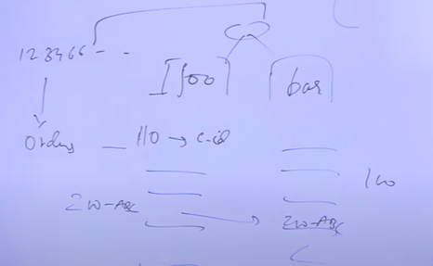

**What is consistency? How to maintain consistency?**

1) Cloud Kitchen system, focus on accepting order through phone number.

2)you **(foo)** note down an order number, the customer id (name). if the customer calls to get an update, check in the notebook (order number & customer name), and tell the order status (ready or not).

3) Getting 10/20 orders/day is manageable, business grows, got 200 orders/day and it is not manageable. So seek help from a friend or business partner **(bar)** is also taking orders

4) Both of them have a notebook accepting order through same number (internally calls are routed)

5) Receive a call enquiry about an order id 120, no order find in notebook, then you realize the partner accepted this order, so both have no idea either accepted order.

6) This is a problem the state of the orders of system becomes **inconsistent,** have to have **consistency** in system otherwise create a bad customer experience

7) Figure out to have consistency between you and partner, both are sharing their orders synchronously **(Replication concept)**, situation 5) solved, this is how you maintain **Consistency**

**What is Availability? What are highly available systems?**

8) Partner falls sick, not accepting any orders. Let’s both are accepting 400 (each 200) orders, now all 400 orders are coming to you, either overtime or not accepting more orders**, so the service is not available, (throughput** **concept**)

9) Now you have 2 or more partners, so at least your system/service is available to some extent. This is called **availability in cap theorem**

10) The term **highly available systems,** means how much request/throughput your system can sustain. For example, the volume of orders grows to 1(5)000 orders/day, are 3 partners can attend/handle the calls/requests, if yes then **system is highly available** if no **system is not highly available.** So **add more partners (10)** then **system becomes highly available** every partner can take 200 orders/day

11) **What would happen to the consistency**, all 10 partners need to synch**. is it possible to have consistency and availability at the same time?**

12) Go back 2 partners, **now they are consistent & available**

**What is Partitioning? What are highly available systems?**

13) The communication channel between you & partner broke, both can’t can talk each other, but both are getting orders, the system overall is **losing consistency.** This is **called** **partitioning**

14) The 2 partners were linked by a communication channel, was responsible of handling consistency of the system, now the channel has broken, so this is **called** **partition**

15) Can tolerate this partition, even though this partition happens able to make system available and consistent then that is **called** **partition tolerance**

16) if you are tolerating a partition would you be able to give consistency and availability in the system?

**CAP in distributed systems/databases/cache/application instances**

Distributed databases **(Replica Concept): 2** dbs have some data. If this consistent, these 2 machines synchronize over the data, have multiple replicas (high availability) of the system. so have consistency and availability, but what is partition tolerance? 2 databases deployed on 2 different instances/hardware machines which would be connected over network, if the network fails no consistent

|  |  |
| --- | --- |
| **Consistency** | **Not possible all in 3 in one system, so pick 2**  **Depend upon on use cases: ATM consistency is must, youtube inconsistency.**  **In interview, Always ask use-case.**  <https://dzone.com/articles/understanding-the-cap-theorem>  [https://mwhittaker.github.io/blog/ an_illustrated_proof_of_the_cap_theorem/](https://mwhittaker.github.io/blog/%20%20an_illustrated_proof_of_the_cap_theorem/)  https://www.infoq.com/articles/cap-twelve-years-later-how-the-rules-have-changed/  visualising the cap theorem |
| **Availability** |
| **Portioning Tolerance** |

**19** **What is Database Sharding, Logical and Physical Shards, Dynamic vs Algorithmic Sharding**

Building a user management(storing lot of users) system, 2 number users storing increases, 3 increase the storage power of the db,. 4 Can’t be increase any many users, in this situation, logical solution is partition or multiple db , that is called **Sharding**.

**Sharding Relational or Non-relational dbs** conceptually same, since structure and schema is different, strategy and implementation is bit different

Lot of data and increasing the storage power of one machine, end up storing data in multiple machines, that is called **Data Partitioning.**

**2 ways scale/partitioning database – Vertical or Horizontal Partitioning**

|  |  |
| --- | --- |
|  | For example Db server which currently store 1M users & storage capacity is 256 GB. It increases to 2 & 4M and 512GB & 1TB. Now this is **maximum you can increase**. Then increase to 8 or 16M, **divide this data into multiple databases**. So you have 4M/1TB database. You partition your data, divided data into different parts, all them combined represent to complete database. |

**How can you partition/break this data?**

|  |  |
| --- | --- |
| For example, User table – 1 to 4 records of city, date, event data. **2 ways** to partition this table. | **Way 1**, store all columns in different db partition (like user in db1, date db2, citydb3, and event db4 **OR** user & date in db1, city db2, like any combination). This is called **Vertical Partitioning**  **Way 2**, divide the rows, put 1m in db1 partition and 2m in db2,..like that. This is called **Horizontal Partitioning, HP Is same(Known) as Sharding.** This is **widely using the techniq**ue for storing large data or highly availability/scalable database. |
|  | **Shards** is partitioning or subset of whole data. Subset could be **logical or physical** shards.    Each 1M records divided into 4 partitioning, 0-1m records in part 1, 1.1-2 in 2, 2.1-3 in 3 and 3.1-4m in 4.    0-1m records in partition 1 is **called logical partitioning(shards)**, but both logical part1 and part2 sit on one machine, this is **called physical partition (shards).**  Same as part3 and part4 in **machine 2. It means physical machine holds 2 logical partitions of data.** |

**Advantages –** **1** Not able to **store data** in one machine, so partition. **2** **Query optimization**, better performance and reduce latency. Search query will be slow because it search whole 4m.

But if it search only Shards is fast, means it search ¼ of the db. **3** Place physical shads in **different geography** locations (Apps Tinder, manly) **4** if only one db & crash (even though replication),

this is **single point of failure**, if you have multiple instance, even if one is down, still you can serve.

**Concepts of different sharding strategies - Algorithm or Dynamic Sharding**

|  |  |
| --- | --- |
|  | App (client) is using (sending/receiving request) the dbs. If app knows the logic or function using which it can find out which shards/partition read or write has to go to. This is called **Algorithm Sharding**.  So one function/logic kept in client which take some properties of your table (user id or city) and it gives you the result that which shard you read or writes has go to. Because **your client knows where read or writes request has to be routing**.  There is another service/module, which tells where the query has to be routed to. In this case client takes to this **dynamic sharding module or locator service** |

**Disadvantage of Sharding:** Sharding is **complex. 1** Choosing **key not correctly**, some db has more or less data, that is called **hotspots** (query is slower (lot of data or over loaded). **2.** Once you have partitioning data, bring back to one database (or non-sharded way), it is going to be problem **3.** If queries require joins from different machines or search one db and another db, **it take lot of time or expensive 4.**All dbs are **not providing sharding,** you have to **manually implement.**

**Sharding Strategy – Key, Range, Directory based starategy, many more strategy or combination of first 3**

|  |  |
| --- | --- |
| **How to use a Sharding key?** Choose a static in nature, key value should not change frequently. For example if you choose city, tmr city will be change for the person.  **City based key, like Netflix**  **You can choose combination of column.** | **Key based sharding –** Shards key Is **not same as primary key** of table. Primary key can be shared key but not vice versa. Userid is key, use this value to find out which shards it has to route. **Way 1 Hashing function,** which will give 1 or 2**.** Hash always generate same value when read or write. This is called **Algorihmatic Sharding**. App has hash function.  **Advantage: 1** Data is **evenly distributed**  **Disadvantage:** 2 When the data increase/decrease & new/remove shard adding, then you’re **hashing function has to change**, you have to move your data from s1, s2 to new shard s3. |
| **Disadvantage: 1** More used in the month of jan/feb when the discounts going on and it is less used from there onwards, in this case the chart which is storing (jan/feb) ata will have a lot of data reads and writes. This is called **Hotspot. 2** the data is **not uniformly distributed**  **Use cases: 1** user names can divide like all the user names starting from a to f on one shard. There could be HotSpots also. | **Range based sharding**  **Example1** Storing the event logs of users (time stamp, activities), this data has to be available in terms of date or months. Divide this data on the basis of dates or months. 6 shards data in terms of months, 2 months data in one chart. From event log, check the date and then check in which range this date falls.  when a query all the login details for January, 1st shard has to be queried  **Example 2**: E-commerce system store different items on the basis of price range right (<100, 100-500)  This can be done in the algorithm or the application code  **Advantage** - **1** Have same db schema for all your logical and physical charts you don't have to change  how the rows look or how the schema of the rows  **2** No hashing function, can add more machines, no moving data |
| **Advantage: 1)** Add/remove more zones, it’s dynamic without touching other shads **2** Like Range based Hotspots.  Disadvantage: 1 Every reads and write, application has to connect lookup table, **it increase the latency** **2** lookup crash (single point of failure), all are down.  Solution is replication, but it’s expensive | **Directory based (Dynamic Sharding) –means** store where the sharding information is kept in lookup table or somewhere else other then application or database and that lookup table tells where are rows are located of logical or physical**.**  **Example:** users are divided by basics of the countries and zones, whenever reads or writes, it comes to the application, application has to connect the lookup table, then it looks  It’s like Directory<Key,Value> |

**20 Hashing, Consistent Hashing**

|  |  |
| --- | --- |
|  | **What is hashing?** Put the any data into some function or computing, which gives you a result which is called **hash or hash code. Hash code** usually is a integer value or can be anything |
|  | **how hashing helps us or is actually useful? A real world example:** Put the names through a hash function, which generates a value, like the value 12 is generated for ankit, neha (42), anchor (34) and Ruchi (67). |
| **Range of the hash** values from 0 to 2 raised 32. | List of names, try to search, if it’s sorted alphabetical, it will take complexity n log n. if not sorted, take n.  Put all of this data in array & mapped to integers (like 12 42 34), these values actually are **array indices**. The access time for this value **becomes constant 0(1)**.  **Advantage**: if it hash, you can access a fast manner.  **Can’t keep** big array in order to just store these or 10,000 names. If map the hash values with the large array indexes, which will be a **waste of a lot of space.** |
|  | After calculating the hash, take a **modulus.**  Storing 4 names, take twice or thrice the size of array or data might grow by 2x or 3x, so let's take an array of size 8. The values 12, 42, 34, 67 after **mod 8**, get converted into single integers like 4, 2,2, 3 |
|  | Apply modulus, the 42 and 34 turned out to be 2, suppose if 1 more name as ankit, end up in the **same index.** So in this try to **save a list index** instead of saving 1 string. Still is going to be **n by k. W**here you have 2 values in same index, is called **collision** |
| **Hashing use cases** | 1. One of the popular use cases of hashing is saving **key/value pairs** which help in caching (like **redis or memcache**).  Can store a lot of key value pairs in 1 machine or distributed across multiple machines  Save these names in some servers (have 4 servers), take the values 16, 25, 30, 23 mod 4 (have only 4 values to store to 4 locations). The name Ankit goes to server 0 (S0). |
| **What we have to do with existing keys**      This ruchi string has to be assigned to either s0 or s1 or s2.  **So lot of data is moving, this is the problem for normal hashing**  **Consistent hashing** is solution for this problem | 2 Server decrease, because of load reduced. **Get rid of one of the server (s4)**.  In order to accomplish that redistribute the keys. The modulus number will change to 3 instead of 4 because of server reduced    So the distribution of these values to different servers is also going to change, like 16 modulo 3 becomes 1. So in this not only Ruchi, other keys also got reassigned. 75% of the keys got reassigned. |
| **Consistent Hashing - put hash generated values on a circle right**    **how these are mapped is hidden into the implementation details**  **how are we going to map which server this value sits on or which server this particular key/value goes**    **the server names /values are also going to lie in the circle**    **which is mapping these values to servers how are we going to know that where will 12 sit variable 34 sit level 67.**  **There are 2 implementations - either you can go clockwise or anticlockwise**    **use clockwise - 42 sit on s3, 34 sit on s2, 67 sit on s1 and 12 try to move clockwise s3 is the first server sits on. this way you map your values to servers.**  **this is how inconsistent hashing you map the key values to different servers.**  **solving the actual problem to remove a server to remap a lot of keys. S3 removed**    **what is the problem with this approach? S2 is overloaded. the distribution of keys is uneven**    **replicating s1, s2 and s3**  **create replicas of s1,s2,s3 - s1c s2c s2c s1c s3c s3c and s1c. for every server there are 2 or 3 copies**  mapped    Remove s3 server and all s3 replica also - **now s1 - only one key had to be demand**  **from this example, no replicated copies, remap 50% of the keys but using replicas remap only 25%**  https://www.toptal.com/big-data/consistent-hashing | |